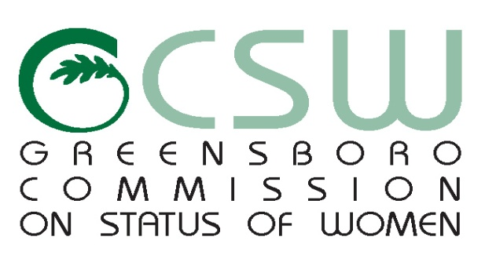

**CSW AGENDA**

April 24th 6pm 2018

Greensboro Cultural Center

200 N. Davie Street. Room 101 H

***Mission: To improve the quality of life for women in Greensboro***

1. **CALL TO ORDER**
2. **MOMENT OF SILENCE**
3. **VISITORS**
4. **CHAIR REPORT**
5. **COMMITTEE REPORTS**

* Domestic Violence
* Education & Equality
* Health & Wellness
* Women Leading Through Service

1. **STAFF REPORT**
2. **OTHER BUSINESS : Review Minutes**
3. **ANNOUNCEMENTS & UPCOMING COMMUNITY EVENTS**
4. **ABSENCES**
5. **ADJOURNMENT**

*Any individual with a disability who needs an interpreter or other auxiliary aids or services for this meeting may contact the Human Relations Department at 373-2038 or 333-6930 (TDD).*

[www.greensboro-nc.gov](http://www.greensboro-nc.gov)