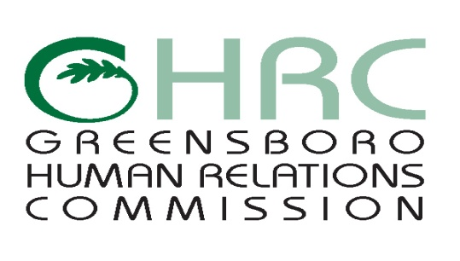

**HUMAN RELATIONS COMMISSION**

**AGENDA**

February 7, 2019

***MMOB****, 300 W. Washington Street, Plaza Level Conference Room*

1. **CALL TO ORDER**
2. **MOMENT OF SILENT MEDITATION**
3. **SPEAKER**
4. **CHAIR’S REPORT**
5. **COMMITTEE REPORTS**

* Education Committee
* Employment Committee
* Human Services & Social Equity Committee
* Montgomery/Wells Housing Committee
* International Advisory Committee

1. **STAFF REPORTS**
2. **ITEMS FOR COMMISSION’S DISCUSSION AND VOTE**

* Goals and objectives of the committees (Dr. Crossling)
* Commissioners' involvement in the committees
* Commissioners' Availability (Purpose: coordination of event attendance)
* Commissioners' Direct outreach events in the communities
* HRC's budget?
* January 10th Meeting Minutes

1. **OTHER BUSINESS**
2. **ABSENCES**
3. **ADJOURNMENT**

*Any individual with a disability who needs an interpreter or other auxiliary aids or services for this meeting may contact the Human Relations Department at 373-2038 or 333-6930 (TDD).*

Web Page address: [www.greensboro-nc.gov](http://www.greensboro-nc.gov)