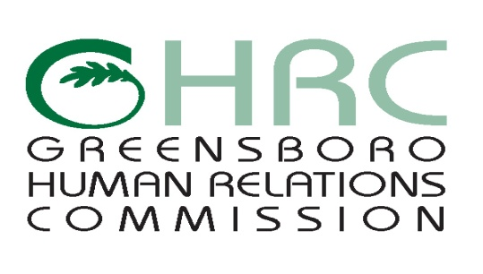

**HUMAN RELATIONS COMMISSION**

**AGENDA**

November 9, 2017

*Meeting Room,* ***YWCA****, 1807 E. Wendover Avenue*

1. **CALL TO ORDER**
2. **MOMENT OF SILENT MEDITATION**
3. **CHAIR’S REPORT**
4. **COMMITTEE REPORTS**

* Police Community Review Board (PCRB)
* Education Committee
* Employment Committee
* Human Services Committee
* Montgomery/Wells Housing Committee
* International Advisory Committee
* Committee for Social Equity

1. **STAFF REPORTS**
2. **ITEMS FOR COMMISSION’S DISCUSSION AND VOTE**

* October 5th Meeting Minutes

1. **OTHER BUSINESS**
2. **ABSENCES**
3. **ADJOURNMENT**

*Any individual with a disability who needs an interpreter or other auxiliary aids or services for this meeting may contact the Human Relations Department at 373-2038 or 333-6930 (TDD).*

Web Page address: [www.greensboro-nc.gov](http://www.greensboro-nc.gov)