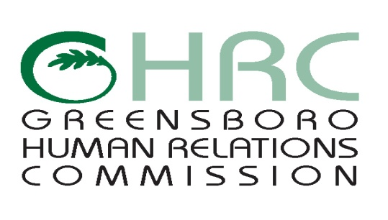

**HUMAN RELATIONS COMMISSION**

**AGENDA**

June 29, 2017

*Meeting Room,* ***YWCA****, 1807 E. Wendover Avenue*

1. **CALL TO ORDER**
2. **MOMENT OF SILENT MEDITATION**
3. **CHAIR’S REPORT**
4. **ITEMS FOR COMMISSION’S DISCUSSION AND VOTE**
5. **OTHER BUSINESS**
6. **ABSENCES**
7. **ADJOURNMENT**

*Any individual with a disability who needs an interpreter or other auxiliary aids or services for this meeting may contact the Human Relations Department at 373-2038 or 333-6930 (TDD).*

Web Page address: [www.greensboro-nc.gov](http://www.greensboro-nc.gov)