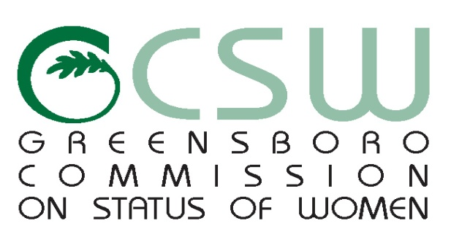

**AGENDA**

*March 28th 2017 at 6pm*

*Greensboro Cultural Center*

*200 N. Davie Street. Room 203*

***Mission: To improve the quality of life for women in Greensboro***

1. **CALL TO ORDER**
2. **MOMENT OF SILENCE**
3. **VISITORS**
4. **CHAIR REPORT**
5. **COMMITTEE REPORTS**

* Domestic Violence
* Education-Vacant
* Equality
* Health
* Services to the Aging
* Women Leading Through Service

1. **STAFF REPORT**
2. **OTHER BUSINESS ( Review Minutes )**
3. **ANNOUNCEMENT OF UPCOMING CSW & WOMEN EVENTS**
4. **ABSENCES**
5. **ADJOURNMENT**

*Any individual with a disability who needs an interpreter or other auxiliary aids or services for this meeting may contact the Human Relations Department at 373-2038 or 333-6930 (TDD).*

[www.greensboro-nc.gov](http://www.greensboro-nc.gov)