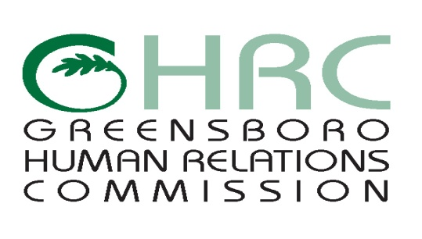

**HUMAN RELATIONS COMMISSION**

**AGENDA**

June 9, 2016

*Meeting Room,* ***Central Library (Tannenbaum Room)****, 219 N. Church Street*

1. **CALL TO ORDER**
2. **MOMENT OF SILENT MEDITATION**
3. **RECOGNITION OF VISITORS AND SPEAKERS**

Tom Carruthers City Attorney, Greensboro Legal Department

Maseta Dorley Turning Point 180

1. **CHAIR’S REPORT**
2. **COMMITTEE REPORTS**

* Complaint Review Committee (CRC)
* Education Committee
* Employment Committee
* Human Services Committee
* Montgomery/Wells Housing Committee
* International Advisory Committee
* Native American Committee

1. **STAFF REPORTS**
2. **ITEMS FOR COMMISSION’S DISCUSSION AND VOTE**

* May 5th Meeting Notes

1. **OTHER BUSINESS**
2. **ABSENCES**
3. **ADJOURNMENT**

*Any individual with a disability who needs an interpreter or other auxiliary aids or services for this meeting may contact the Human Relations Department at 373-2038 or 333-6930 (TDD).*

Web Page address: [www.greensboro-nc.gov](http://www.greensboro-nc.gov)