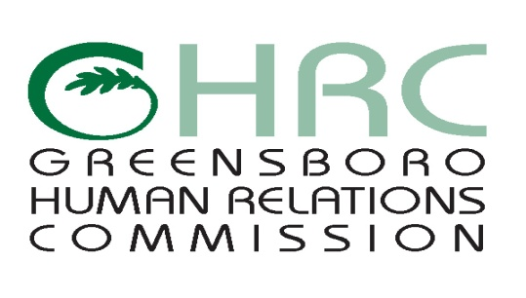

**HUMAN RELATIONS COMMISSION**

**AGENDA**

December 3, 2015

*Greensboro Cultural Arts Center, 200 N. Davie St.*

1. **CALL TO ORDER**
2. **MOMENT OF SILENT MEDITATION**
3. **VOTING**
4. **ADOPTION OF JOINT POLICE REVIEW BOARD RESOLUTION**
5. **ADJOURNMENT**

*Any individual with a disability who needs an interpreter or other auxiliary aids or services for this meeting may contact the Human Relations Department at 373-2038 or 333-6930 (TDD).*

Web Page address: [www.greensboro-nc.gov](http://www.greensboro-nc.gov)