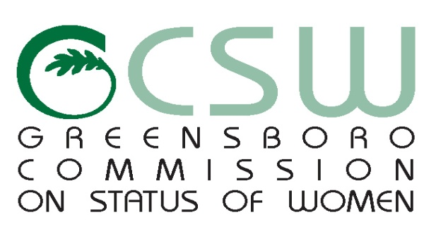

**AGENDA**

October 27, 2015

NC A&T (Merrick Hall)

*Mission: To improve the quality of life for women in Greensboro*

1. **CALL TO ORDER**
2. **MOMENT OF SILENCE**
3. **RECOGNITION OF VISITORS**
4. **CHAIR’S REPORT**
5. **ELECTIONS**
6. **COMMITTEE REPORTS**

* Education
* Health
* Equality
* Domestic Violence
* Services to the Aging
* Women Leading through Service

1. **STAFF REPORT**
2. **ANNOUNCEMENT OF UPCOMING CSW AND WOMEN EVENTS**
3. **EXCUSED ABSENCES**
4. **ADJOURNMENT**

*Any individual with a disability who needs an interpreter or other auxiliary aids or services for this meeting may contact the Human Relations Department at 373-2038 or 333-6930 (TDD).*

[www.greensboro-nc.gov](http://www.greensboro-nc.gov)