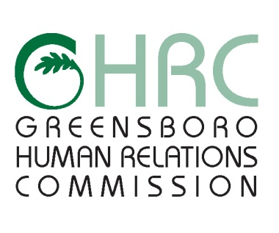

### HUMAN RELATIONS COMMISSION

### AGENDA

March 5, 2015

*Board Room #112, Cultural Arts Center, 200 N. Davie Street*

1. **CALL TO ORDER**
2. **MOMENT OF SILENT MEDITATION**
3. **RECOGNITION OF VISITOR**
4. **CHAIR’S REPORT**
5. **COMMITTEE REPORTS**

* Complaint Review Committee (CRC)
* Education Committee
* Employment Committee
* Human Services Committee
* Montgomery/Wells Housing Committee
* Program and Planning Ad Hoc Committee
* DACA and In-State Tuition follow-up discussion
* IAC Working Group

1. **STAFF REPORTS**
2. **ITEMS FOR COMMISSION’S DISCUSSION AND VOTE**

* February 5th, 2015 Meeting Minutes

1. **OTHER BUSINESS**
2. **EXCUSED ABSENCES**
3. **ADJOURNMENT**

*“*Any individual with a disability who needs an interpreter or other auxiliary aids or services for this meeting may contact the Human Relations Department at 373-2038 or 333-6930 (TDD).

Web Page address: [www.greensboro-nc.gov](http://www.greensboro-nc.gov/departments/Relations/women)